CARE and MAINTENANCE

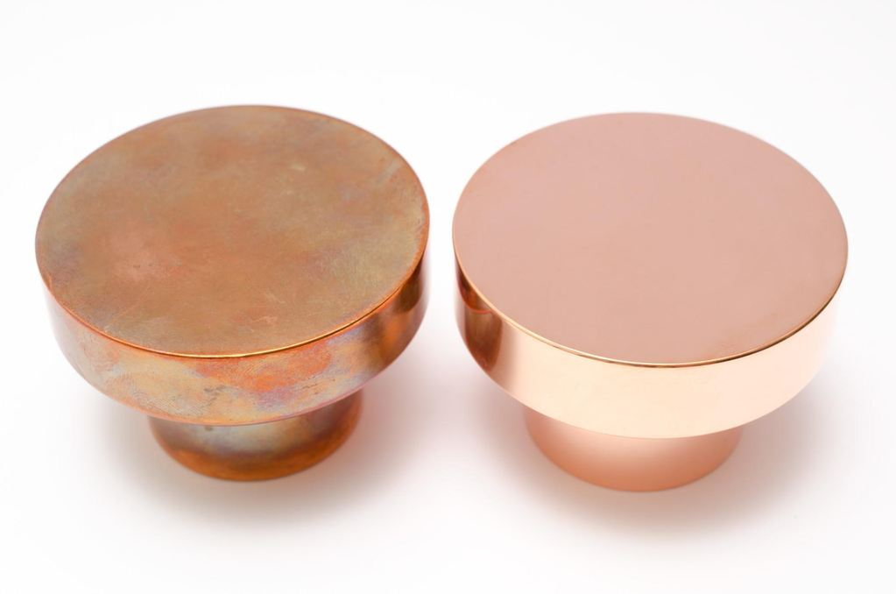

BRASS & COPPER
Our brass and copper products are solid brass and copper. Since both are living materials without any finishes or other chemical treatments, they will oxidize and age with time (as the picture shows). Either let them age with grace, turn blotchy and darken beautifully or maintenance them by polishing them regularly. For best maintenance use our own cleaner PUTS. (Please read further down for more information).
CHROME
Our chromed series is a finely chrome-coated brass. The same chrome as used on car and boat parts. It is both beautiful and durable. Use washing up liquid or our own PUTS cleaner for best result when cleaning.
ALUMINIUM
Our aluminium products are solid aluminium with a brushed finish. Use washing up liquid or our own PUTS cleaner for best result when cleaning.
A FEW TIPS
Brushed surfaces should not be cleaned with polish containing abrasives, as there is a risk of the surface turning shiny. Our own cleaner PUTS is a good and gentle option to use on brushed surfaces for example.
PUTS cleaner
PUTS is our own cleaner that is perfect for cleaning brass, copper, chrome and aluminium products. It works on most metal surfaces as stainless steel, chrome, copper, brass, aluminium, nickel, silver and gold.
HOW TO USE OUR PUTS
Apply a small amount of PUTS on a damp cloth and rub gently on product until all stains are gone. Rinse away any excess cleaner with lukewarm water and wipe dry with a cotton cloth as quick and thoroughly as possible.
Nails and skin may turn white when in contact with PUTS. Wear plastic gloves when applying the cleaner.
DOES YOUR POLISHED BRASS & COPPER PRODUCTS LOOKS TARNISHED / OXIDIZED?
Use AUTOSOL CREAM POLISH to shine. When using AUTOSOL CREAM POLISH make sure to dismantle hanger/knob from wall or drawer before shining because the cream polish turns black when using.
Put a small amount of polishing cream on a dry cloth and polish carefully in the same direction. When the surface is nice and shiny, wipe off the excess cream with a clean soft cloth. Don´t use water togehter with AUTOSOL CREAM POLISH.
DO NOT use on chrome or brushed surfaces.
You are more than welcome to contact us with any further questions.

